Version 2026-04-03 09:04, Eric Pohl

Software
There are 5 main processing steps for
- Read out the loggers (atmosphere and water)
- Correction and homogenization of water level data
- Calculation of discharge from the tracer experiments
- Calculating the relationship between water level and discharge (“rating curve”)
- Transform the water level time-series into discharge time-series.
Each processing step is separately treated and requires specific software. We will showcase an example for each of the steps. For three steps (2, 3, 4, and 5) the programming software R or Python is used, and we provide a separate example for these steps on the computing and teaching platform https://renkulab.io . It is also possible to install the software on your own computers. A guide on how to do this is provided in this document as well.
You will find different renkulab projects for the steps 2, 3, 4, and 5. These are in development. Check the website (https://github.com/pohleric/mountain-hydrology-workshop-2026/) to find the corresponding links for each task.

Read out the loggers
The HOBO loggers require the software HOBOware to download the data and start the loggers (https://www.onsetcomp.com/support/help-center/software/hoboware). Additionally, a HOBO Shuttle with an adapter (U20 or U20L) is required (03 – Installation and Tools; Figure 1). After starting the software on your computer, the Shuttle is attached. The logger cap needs to be removed to place the infrared interface into the adapter on the Shuttle. The computer will show that the logger is attached (unless the battery is dead or the logger is broken), and the data can be downloaded and saved in Excel or text format (CSV). It is important to never expose the infrared interface of the logger to direct sunlight! This might cause the logger to break and to lose all data.
The van Essen loggers require the software Diver Office to download the data (https://www.vanessen.com/products/software/diver-office/). There is also a USB device required to read out the loggers (Figure 2).
All data from the atmosphere and the water level need to be stored on your computer. You should directly choose a filename and a folder structure that makes processing easy. The example on renkulab.io uses a folder structure that organizes the atmospheric and water pressure data like this: “HOBO/data/KG_G354/atmo” and “HOBO/data/KG_G354/water” for the example of Glacier 354. The filename should reflect the type, time-period, and processing level, e.g. “10778182_atmo_2019-2021_L1.csv” (L1 means that the data has not been processed but only cleaned – removing an “end of line” indication at the bottom of the file.

Correction and homogenization of water level data
The water level logger data needs to be corrected for the atmospheric pressure (01 - Theoretical basis). For this, the air pressure needs to be subtracted from the water level logger data. This is done in the software Python but can also be done manually in Excel. The Python approach is available in the corresponding renkulab project (check https://github.com/pohleric/mountain-hydrology-workshop-2026/) for the correct link. Following the link to the renkulab project you can start the project/software by clicking the “Launch” button. After some time, you will be presented with the computing environment. This environment automates as best as possible the process and includes:
- Automatic time zone correction (everything will in the end be in UTC+0)
- Automatic subtraction of the atmospheric pressure from the water level logger data
- Automatic adjustment of the final water level to correspond to the observed water level when the logger was installed and read out
- Automatic output as CSV file
This approach requires you to provide the true water level reading when you were in the field. This information needs to be provided in the parameter file (params_simple_2026-04-02.yml). Figure 1 gives an example of how the information needs to be provided in the parameter file. It is possible to estimate the depth of the sensor if was not measured. The estimate/measurement of the depth must be provided under “base_levels”. It is possible to provide multiple measurements per year, e.g. for 2019: “2019: [30, 25]”, and must be matched with the corresponding uncertainties and dates in that case under “base_level_uncertainties” and “base_level_dates”, e.g. for 2019 on the 24th of August at 7:00 and 12:00 : “2019: [10, 10]” and “2019: [‘2019-08-24T07:00:00+06:00’ , ‘2019-08-24T12:00:00+06:00’]”. You should provide a full hour estimate like 07:00:00 instead of 07:15:24. The output file is written automatically based on the name of the site defined in the parameter file. In this example “KG_G354-old”
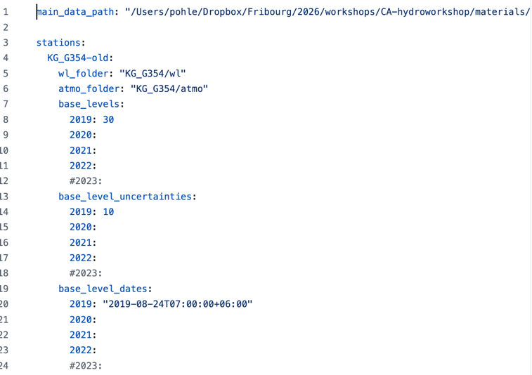
Figure 1: Paramter file for the water level homogenization.

Calculation of discharge from the tracer experiments
For the calculation of discharge through the tracer experiments (FL30), Excel (or another spreadsheet program), and the software R + RStudio are required. The Excel software is needed to split all recorded measurements into individual measurements. The RStudio software allows to select measurements using the mouse and to transform the instrument file (binary format) into readable text format with units in mV.
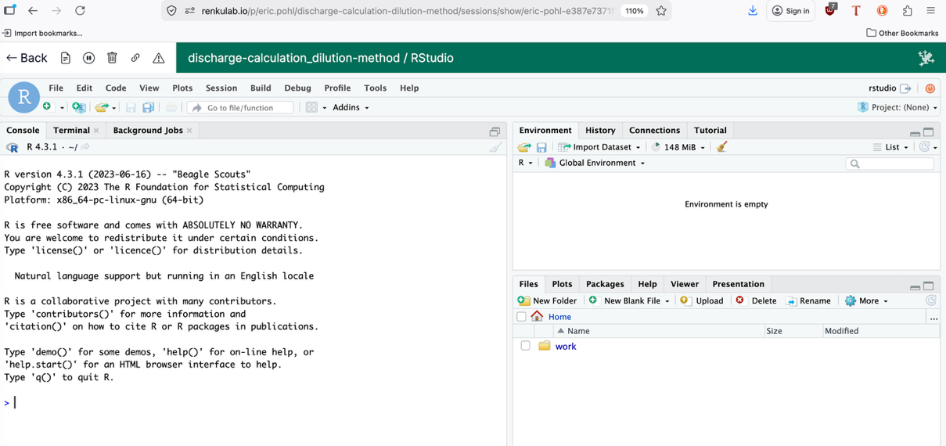
Figure 2: renkulab RStudio version. Online at: https://renkulab.io/p/eric.pohl/discharge-calculation-dilution-method.
The prepared renkulab project can be found here: https://renkulab.io/p/eric.pohl/discharge-calculation-dilution-method. After starting the project (“Launch” button), you will see an online version of RStudio with an example for Glacier 354 prepared. For each measurement, an estimate of discharge is calculated in RStudio. These final estimates need to be manually put into a separate Excel file. These measurements will serve for the next step.

Calculating the relationship between water level and discharge (“rating curve”)
The relationship between the corrected and homogenized water level (Section 7.2) and discharge (Section 7.3) is calculated in Python. The link for this step will be available on https://github.com/pohleric/mountain-hydrology-workshop-2026/.

Transform the water level time-series into discharge time-series
The final transformation of the corrected and homogenized water level data (Section 7.2) into a continuous discharge time-series is based on the same project on renkulab as for Section 7.4. The link for this step will be available on https://github.com/pohleric/mountain-hydrology-workshop-2026/.

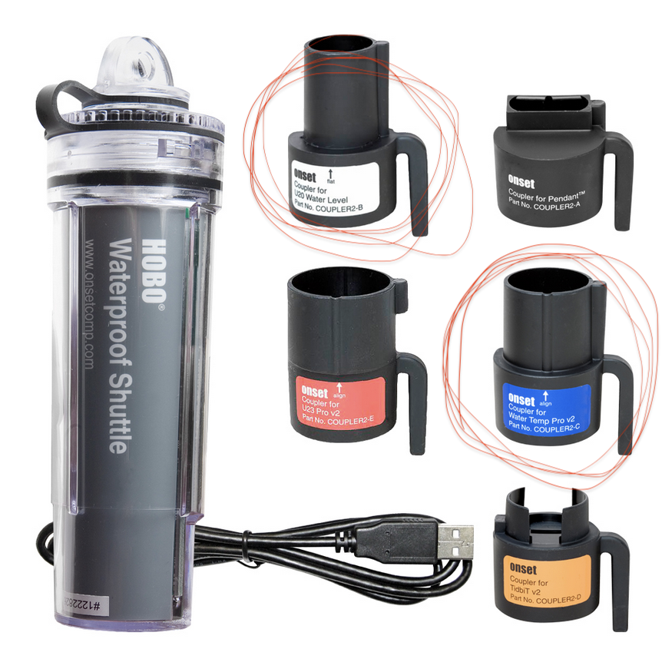
Figure 3: HOBO Shuttle with adapters (one for the U20, and one for U20L loggers)
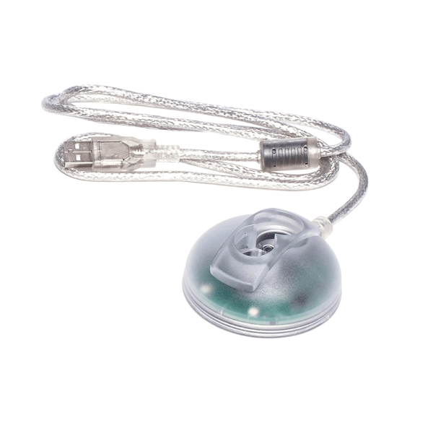
Figure 4: van Essen Diver USB Reading Unit.

Software installation on your own computer
You can install all programs on your own computers as well. There are multiple steps involved. This is why we are using mostly the renkulab.io platform. Here is a brief outline of how to install the R, RStudio, and Python software.

R + RStudio
R can be downloaded via https://cran.r-project.org/bin/windows/base/. After installing the downloaded installation file, you then have to download and install RStudio (first R then RStudio). The download file can be found here: https://posit.co/downloads/. The installation file will create a Desktop Launcher. Simply open the program RStudio by double clicking the launcher icon on your Desktop.

Python
To install the Python software, you should install the Anaconda or Miniconda Installers. First, download the installer from https://www.anaconda.com/download, create an account (free), and chose the “Graphical Installer”. After executing the installer file, you will be guided through the installation. Anaconda/Miniconda is not Python. It will help us install Python in a way that we require it.
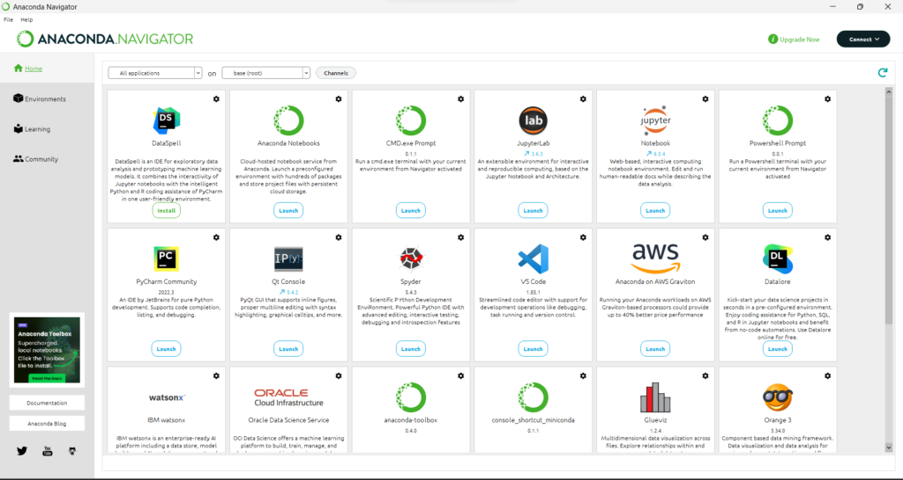
Figure 5: Anaconda Graphical User Interface. You can launch JupyterLab from here.
From the graphical user interface (Figure 5), you can click on “Environments”. Here we must install some packages. You can search for the required packages using the search function and confirm their installation. You will need the following packages for the programs to run:
- Matplotlib
- Pandas
- Yaml
- Re
- Pathlib
- Jupyter

Back in the graphical user interface “Home”, you can start JupyterLab, which will open a new window in your main browser. This will then look exactly as on renkulab.

